Wi-Fi Frame

📡 What Is a Wi-Fi Frame?
# Source: Chatgpt (GPT‑5 Mini) at [12/14/2025]
A Wi-Fi frame is a data structure used in wireless networks (IEEE 802.11) to organize, transmit, and manage data between wireless devices (like laptops, phones, and routers). It plays the same role as an Ethernet frame, but adapted for wireless communication, including security, mobility, and retransmission control.

🧠 Simple Definition:
# Source: Chatgpt (GPT‑5 Mini) at [12/14/2025]
A Wi-Fi frame is a wireless Layer 2 (Data Link Layer) frame used to carry data and control information over a Wi-Fi (802.11) network.

📦 General Structure of a Wi-Fi Frame
# Source: Chatgpt (GPT‑5 Mini) at [12/14/2025]
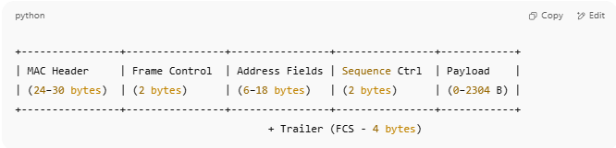
+----------------+----------------+----------------+----------------+------------+
| MAC Header | Frame Control | Address Fields | Sequence Ctrl | Payload |
| (24–30 bytes) | (2 bytes) | (6–18 bytes) | (2 bytes) | (0–2304 B) |
+----------------+----------------+----------------+----------------+------------+
+ Trailer (FCS - 4 bytes)

🔹 Key Components
# Source: Chatgpt (GPT‑5 Mini) at [12/14/2025]
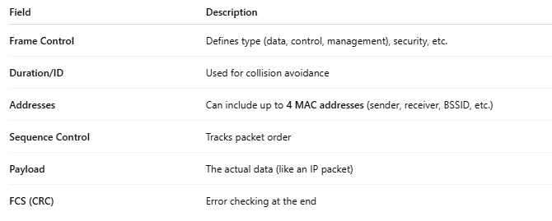
Field | Description
Frame Control | Defines type (data, control, management), security, etc.
Duration/ID | Used for collision avoidance
Addresses | Can include up to 4 MAC addresses (sender, receiver, BSSID, etc.)
Sequence Control | Tracks packet order
Payload | The actual data (like an IP packet)
FCS (CRC) | Error checking at the end

📂 Types of Wi-Fi Frames
# Source: Chatgpt (GPT‑5 Mini) at [12/14/2025]
Wi-Fi uses 3 main frame types:
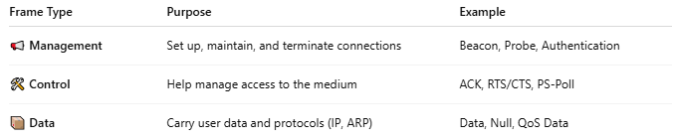
Frame Type | Purpose | Example
📢 Management | Set up, maintain, and terminate connections | Beacon, Probe, Authentication
🛠 Control | Help manage access to the medium | ACK, RTS/CTS, PS-Poll
📦 Data | Carry user data and protocols (IP, ARP) | Data, Null, QoS Data

🧾 Example: Data Frame Fields (Simplified)
# Source: Chatgpt (GPT‑5 Mini) at [12/14/2025]
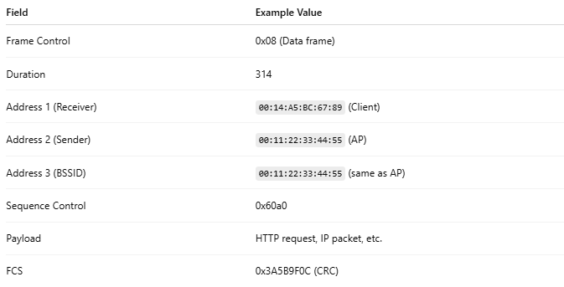
Field | Example Value
Frame Control | 0x08 (Data frame)
Duration | 314
Address 1 (Receiver) | 00:14:A5:BC:67:89 (Client)
Address 2 (Sender) | 00:11:22:33:44:55 (AP)
Address 3 (BSSID) | 00:11:22:33:44:55 (same as AP)
Sequence Control | 0x60a0
Payload | HTTP request, IP packet, etc.
FCS | 0x3A5B9F0C (CRC)

🧠 Visual Example – Wi-Fi Data Frame (802.11)
# Source: Chatgpt (GPT‑5 Mini) at [12/14/2025]
This is a simplified example of a data frame sent from an Access Point (AP) to a Wi-Fi client.
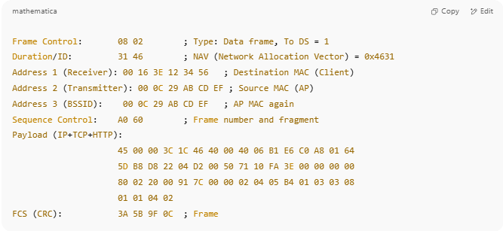
Frame Control: 08 02 ; Type: Data frame, To DS = 1
Duration/ID: 31 46 ; NAV (Network Allocation Vector) = 0x4631
Address 1 (Receiver): 00 16 3E 12 34 56 ; Destination MAC (Client)
Address 2 (Transmitter): 00 0C 29 AB CD EF ; Source MAC (AP)
Address 3 (BSSID): 00 0C 29 AB CD EF ; AP MAC again
Sequence Control: A0 60 ; Frame number and fragment
Payload (IP+TCP+HTTP):
45 00 00 3C 1C 46 40 00 40 06 B1 E6 C0 A8 01 64
5D B8 D8 22 04 D2 00 50 71 10 FA 3E 00 00 00 00
80 02 20 00 91 7C 00 00 02 04 05 B4 01 03 03 08
01 01 04 02
FCS (CRC): 3A 5B 9F 0C ; Frame Check Sequence

📄 Explanation of Fields:
# Source: Chatgpt (GPT‑5 Mini) at [12/14/2025]
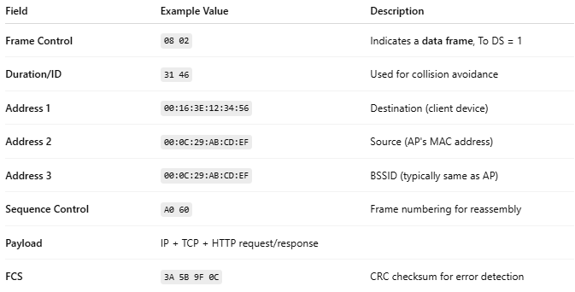
Field | Example Value | Description
Frame Control | 08 02 | Indicates a data frame, To DS = 1
Duration/ID | 31 46 | Used for collision avoidance
Address 1 | 00:16:3E:12:34:56 | Destination (client device)
Address 2 | 00:0C:29:AB:CD:EF | Source (AP's MAC address)
Address 3 | 00:0C:29:AB:CD:EF | BSSID (typically same as AP)
Sequence Control | A0 60 | Frame numbering for reassembly
Payload | IP + TCP + HTTP request/response
FCS | 3A 5B 9F 0C | CRC checksum for error detection

✅ Summary (Structure Overview)
# Source: Chatgpt (GPT‑5 Mini) at [12/14/2025]
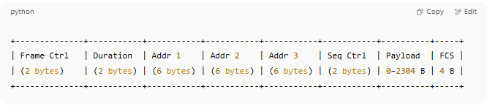
+--------------+-----------+-----------+-----------+-----------+-----------+----------+-----+
| Frame Ctrl | Duration | Addr 1 | Addr 2 | Addr 3 | Seq Ctrl | Payload | FCS |
| (2 bytes) | (2 bytes) | (6 bytes) | (6 bytes) | (6 bytes) | (2 bytes) | 0–2304 B | 4 B |
+--------------+-----------+-----------+-----------+-----------+-----------+----------+-----+

🆚 Wi-Fi Frame vs Ethernet Frame
# Source: Chatgpt (GPT‑5 Mini) at [12/14/2025]
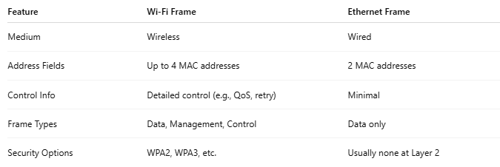
Feature | Wi-Fi Frame | Ethernet Frame
Medium | Wireless | Wired
Address Fields | Up to 4 MAC addresses | 2 MAC addresses
Control Info | Detailed control (e.g., QoS, retry) | Minimal
Frame Types | Data, Management, Control | Data only
Security Options | WPA2, WPA3, etc. | Usually none at Layer 2

📌 Summary
# Source: Chatgpt (GPT‑5 Mini) at [12/14/2025]
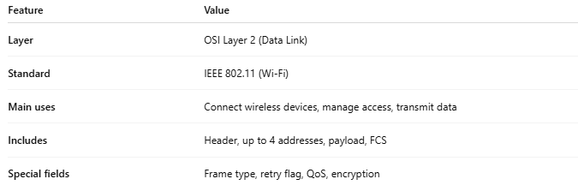
Feature | Value
Layer | OSI Layer 2 (Data Link)
Standard | IEEE 802.11 (Wi-Fi)
Main uses | Connect wireless devices, manage access, transmit data
Includes | Header, up to 4 addresses, payload, FCS
Special fields | Frame type, retry flag, QoS, encryption

